

P.V.G’s COLLEGE OF SCIENCE & COMMERCE,PUNE-09

Department of Computer Science

**Project Report**

On

**❝ONLINE ELECTRONICS SHOPPING WEBSITE ❞**

Submitted to

**THE SAVITRIBAI PHULE PUNE UNIVERSITY**

In Partial fulfilment of

**BACHELOR OF SCIENCE IN COMPUTER SCIENCE**

**(SEM VI)**

Submitted By

**Miss.Salomi Waghmare**

**Mr.Sanskar Ghate**

**Mr.Swaraj Bhagat**

Under The Guidance Of

**Prof. Sapana Mulmule And Ajita Bokil**

Through

**PVG’s COLLEGE OF COMMERCE & SCIENCE PUNE-411009**

**UNIVERSITY OF PUNE 2023-2024**



P.V.G’s COLLEGE OF SCIENCE & COMMERCE,PUNE-09

Department of Computer Science

Project Certificate

This is to certify that ___________________________ has

satisfactorily completed the project as required by

**Savitribai Phule Pune University, Pune** for T.Y.B.Sc.(CS),

Semester-II ,in the academic year 2023-2024.

The title of the project is _____________________________.

Project Guide HOD

Internal Examiner External Examiner

**Acknowledgement**

We would like to express our sincere gratitude to all those who have contributed to the initiation and documentation of our project on **SHOPPING WEBSITE (ELECTRONICS SHOP)**. Their support and assistance have been invaluable in laying the groundwork for this endeavor.

We extend our appreciation to our project supervisor, Mrs.Sapana Mulmule and Mrs.Ajita Bokil ma'am, for their guidance and encouragement throughout this process. Their expertise and insights have been instrumental in shaping the direction of our mini project.

Finally, we would like to express our gratitude to our friends and family for their unwavering support and understanding as we embark on this mini project.

We are deeply grateful for the collective efforts of everyone involved, and we look forward to the successful completion of our Attendance Recorder project.

**Sincerely,**

**Salomi Waghmare**

**Sanskar Ghate**

**Swaraj Bhagat**

**Index**

|  |  |  |
| --- | --- | --- |
| Sr. No. | Title | Page no. |
| 1. | **Introduction** | 4 |
|  |  |  |
| 2. | **System overview** | 4 |
|  |  |  |
| 3. | **Features and modules** | 5 |
|  |  |  |
| 4. | **Technology stack** | **6** |
|  |  |  |
| 5. | **Objective of system** | 7 |
|  |  |  |
| 6. | **Analysis** | **8** |
|  |  |  |
| 7. | **Hardware and software requirement** | **9** |
|  |  |  |
| 8. | **System design** | **10-21** |
|  |  |  |
| 9. | **Advantages** | **22** |
|  |  |  |
| 10. | **Reference** | **23** |

* 1. **Introduction to system**

Step into the future of tech-savvy shopping with our electronic e-commerce haven. Welcome to a realm where innovation meets convenience, offering a curated selection of cutting-edge gadgets, devices, and electronic essentials. Dive into a world of seamless browsing, secure transactions, and unmatched quality. From the latest smartphones to smart home solutions, we're your go-to destination for all things electronic. Embrace the digital era with us and elevate your tech lifestyle effortlessly. Welcome to your one-stop electronic shopping destination. The system is built using PHP, MySQL, PhpMyAdmin, HTML, CSS, and JavaScript technologies.

* 1. **Existing of system**

The existing expenses management system serves as the foundation upon which the PHP project aims to build and enhance. The current system, although functional, lacks the efficiency and user-friendliness desired for seamless expense management. At its core, the system allows users to input and track expenses, categorize them, and generate basic reports. However, several drawbacks hinder its optimal performance. The user interface appears outdated and is not intuitive, leading to difficulties in data entry and retrieval. Additionally, the system lacks advanced features like automated expense approval workflows, integration with external financial platforms, and data visualization tools. These limitations highlight the need for an improved solution that streamlines the process of expense management, enhances user experience, and provides comprehensive insights for better decision-making.

The proposed PHP project aims to enhance the existing expenses management system by modernizing its interface, automating approval workflows, and improving integration with external financial systems. The project's focus is on creating a user-friendly experience through intuitive data entry, interactive visualizations, and seamless automation. By addressing shortcomings and introducing new features, the project aims to offer an efficient and feature-rich expenses management solution that meets the evolving needs of users and organizations

* 1. **Purpose of the system**

The purpose of our system is to provide a user-friendly and efficient platform for seamless online transactions. We aim to offer a diverse range of products, ensuring that users can easily find and purchase items that align with their needs and preferences. Our system prioritizes security to safeguard user information and financial details. With a focus on reliability and convenience, we strive to enhance the overall online shopping experience, creating a digital space where customers can explore, select, and purchase products with confidence and ease.

* 1. **Scope of system**

The scope of our system encompasses a comprehensive online marketplace, offering a wide array of products across various categories. Users can browse, search, and purchase items, ranging from electronics and fashion to home essentials. The system incorporates secure payment methods, order tracking, and user account management for a streamlined experience. Additionally, features such as product reviews and recommendations contribute to a dynamic and interactive platform. Our system aims to accommodate the needs of both customers and vendors, fostering a robust e-commerce ecosystem. As we evolve, the scope may expand to include additional features and product categories, ensuring an ever-improving and enriching experience for our users.

* 1. **Objects of system**

The primary objects of our system include:

**1. User Management**: Facilitating user registration, login, and account management to personalize the shopping experience.

**2. Product Management:** Organizing and presenting a diverse range of products with detailed information, images, and pricing.

**3. Shopping Cart:** Allowing users to add, modify, and remove items before proceeding to secure checkout.

**4. Order Processing**: Efficient handling of orders, including order confirmation, payment processing, and order tracking.

**5. Security Measures:** Implementing robust security protocols to safeguard user data, transactions, and sensitive information.

**6. Vendor Interface:** Providing a platform for vendors to manage their product listings, inventory, and order fulfillment.

**7. Feedback and Reviews:** Enabling customers to leave reviews, ratings, and feedback on products, contributing to a transparent and trustworthy shopping environment.

**8. Customer Support:** Offering channels for customer inquiries, assistance, and issue resolution to ensure a positive customer experience.

**1.6 Feasibility study**

The feasibility study for our e-commerce system involves a comprehensive assessment of technical, economic, and operational aspects to determine the viability and potential success of the project.

**1. Technical Feasibility:**

- Infrastructure: Evaluate the technology required for the platform, ensuring it meets current and future needs.

- Development Tools: Assess the availability and suitability of tools and frameworks for system development.

**2. Operational Feasibility:**

- User Acceptance: Evaluate potential users' willingness and ability to adapt to the new system.

- Training Requirements: Identify training needs for users and staff to ensure efficient operation.

**3. Schedule Feasibility:**

Based on the findings from these feasibility aspects, we can make informed decisions about the viability and potential success of the e-commerce system, guiding further development and implementation strategies.

**7.Hardware and software requirement**

**Software Requirement :**

* XAMPP Server
* Visual Studio Code
* Languages : HTML ,CSS ,PHP,JAVASCRIPT
* Database : MySQL,PhpMyAdmin

**Hardware Requirement :**

* RAM : 128 MB
* Processor : Core i3 Processor
* Hard disk : 2GB

**8. System Design**

**8.1 Entity Relationship Diagram (ER Diagram):**

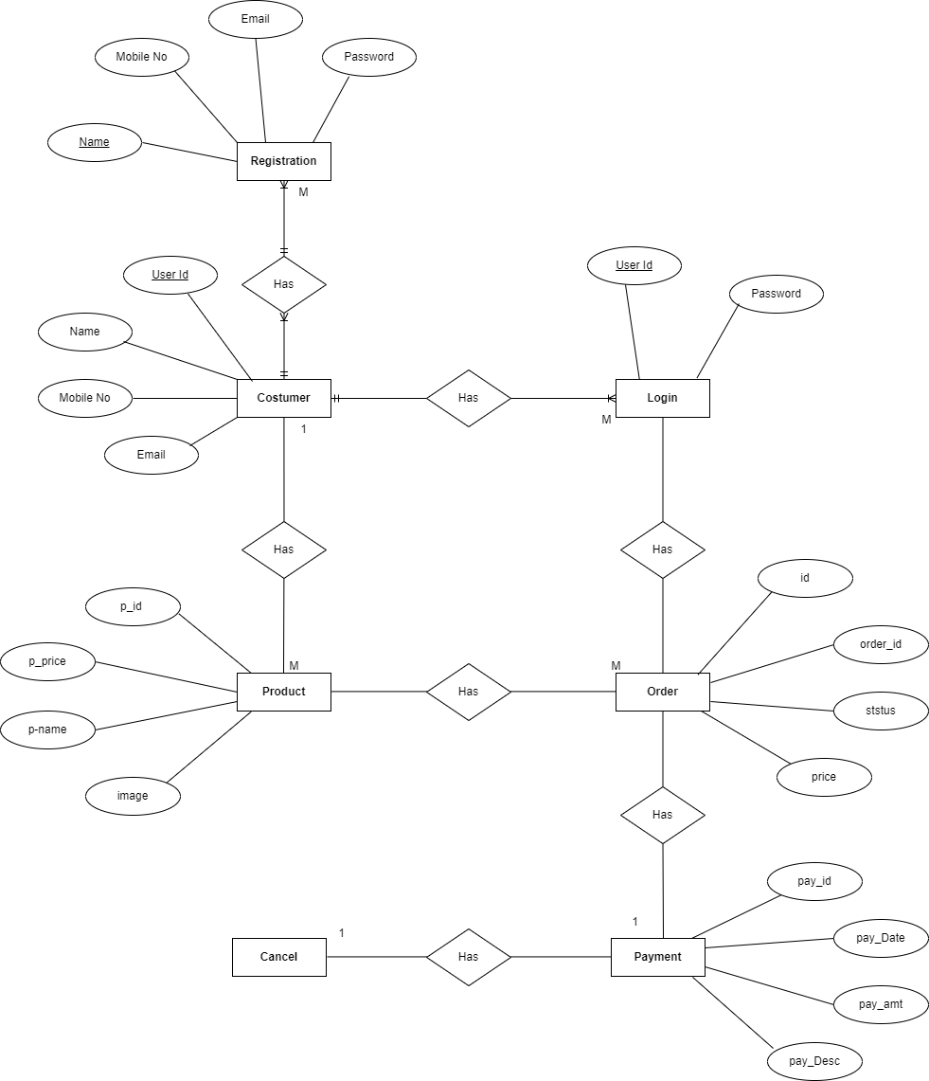

**8.2 Data Flow Diagram**

**1.Zero Level (0.0th level)**

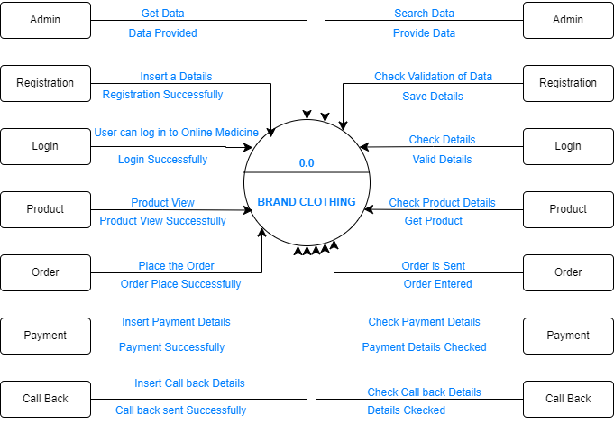

TECH HEAVEN

**2.First Level (0.1st Level)**

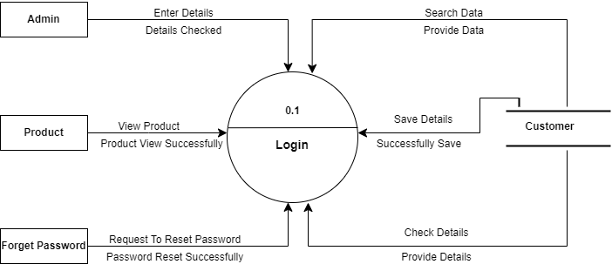

**3.2 Second level (0.2nd level)**

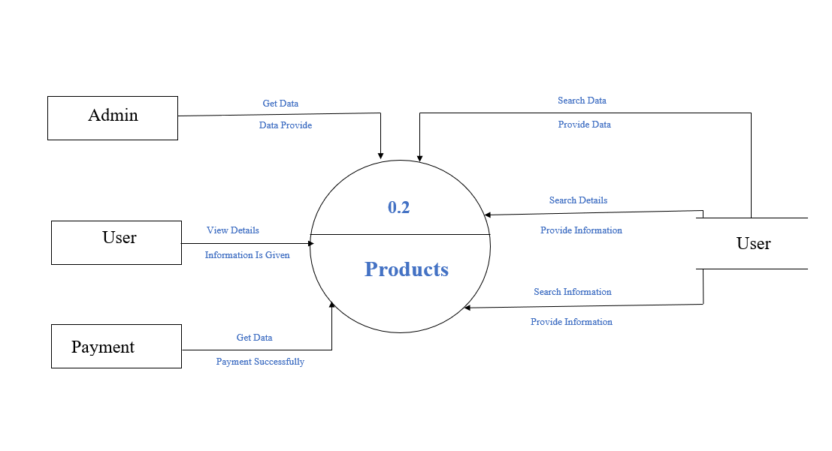

**4.1 Screenshot and Report**

**Home Page:**

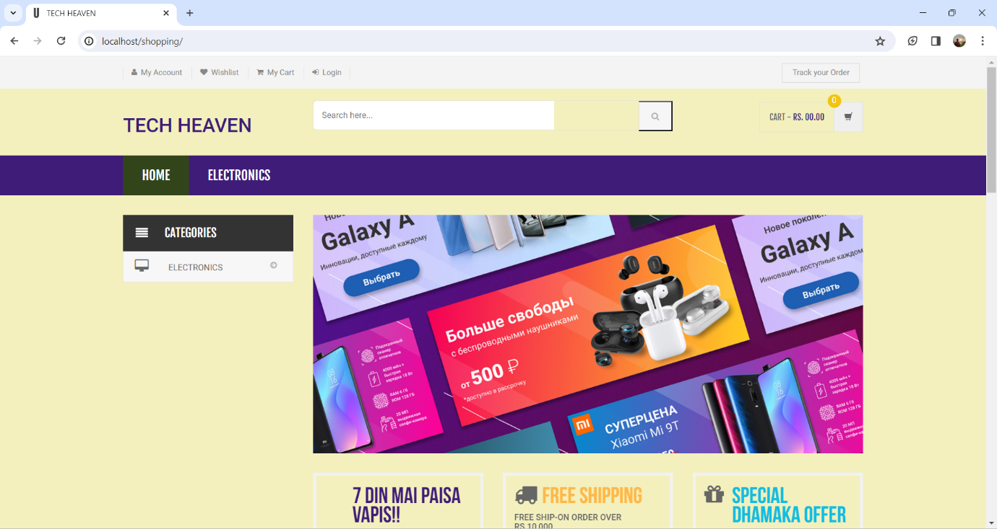

**Categories:**

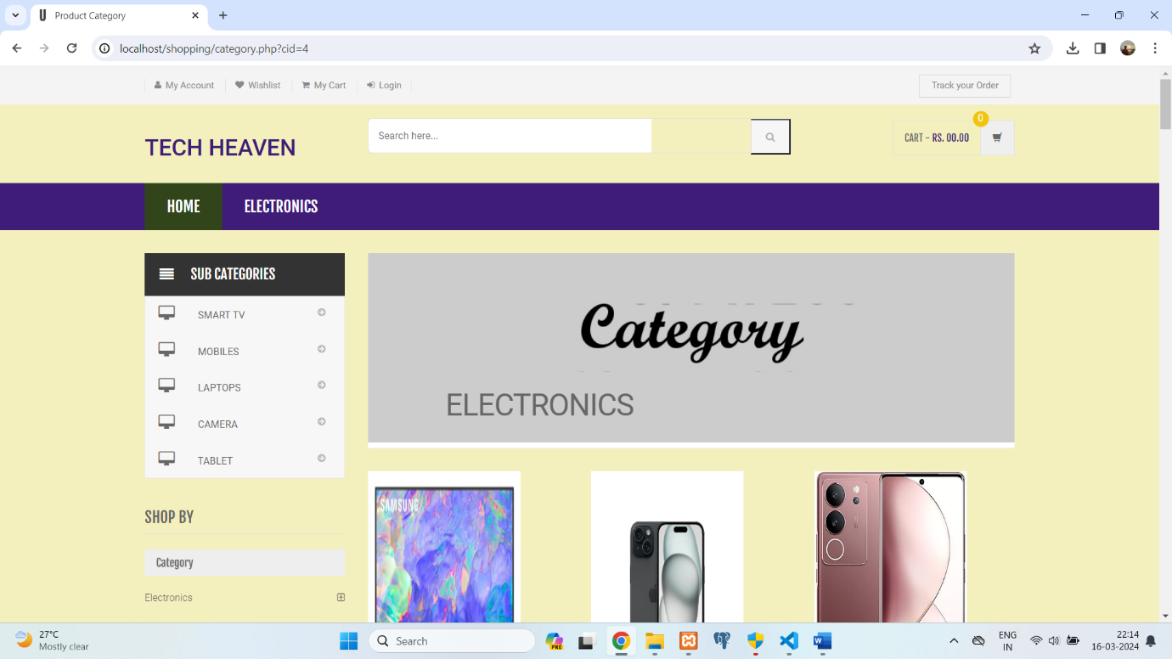

**Footer:**

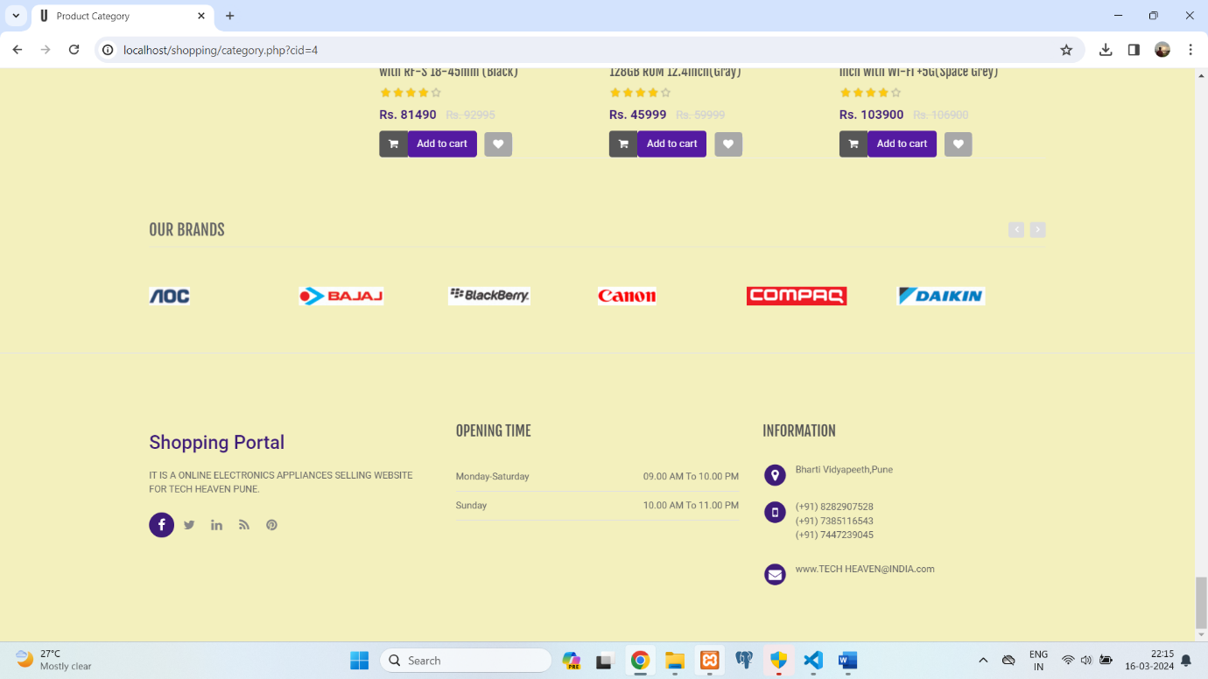

**Admin login:**

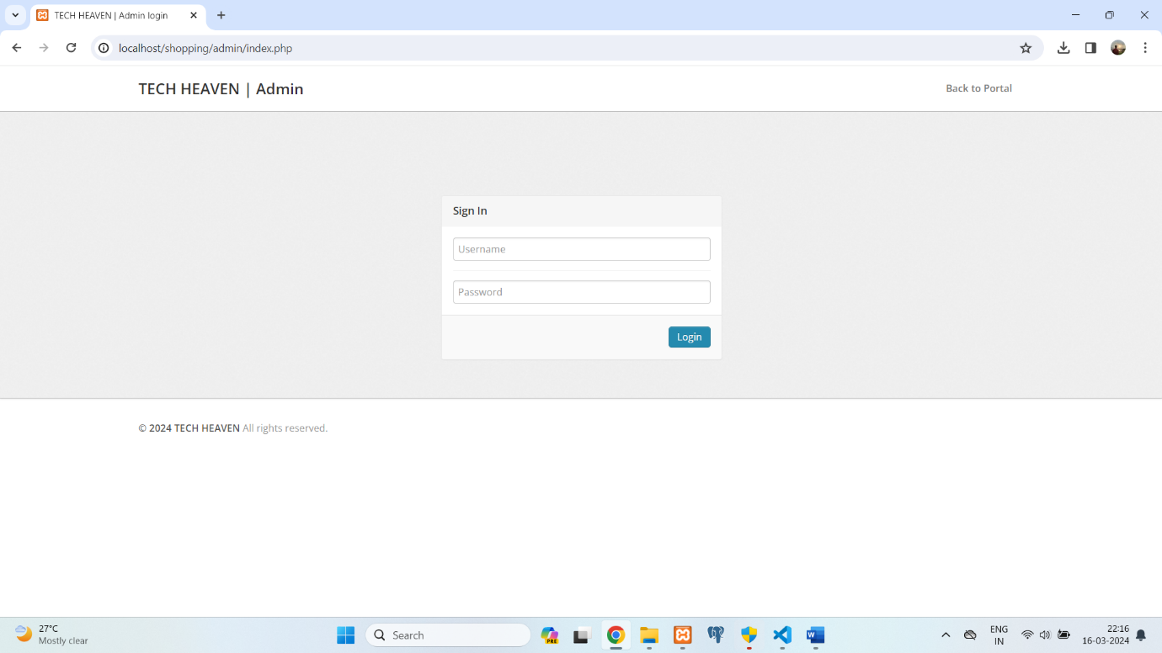

**Admin :**

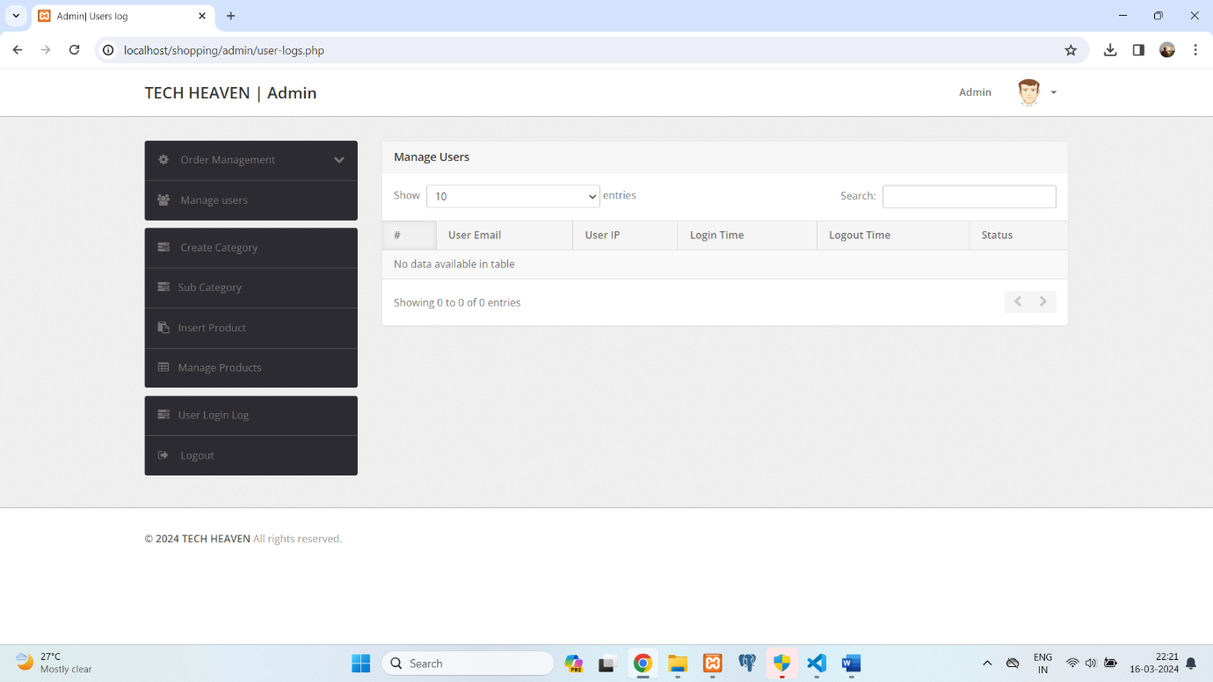

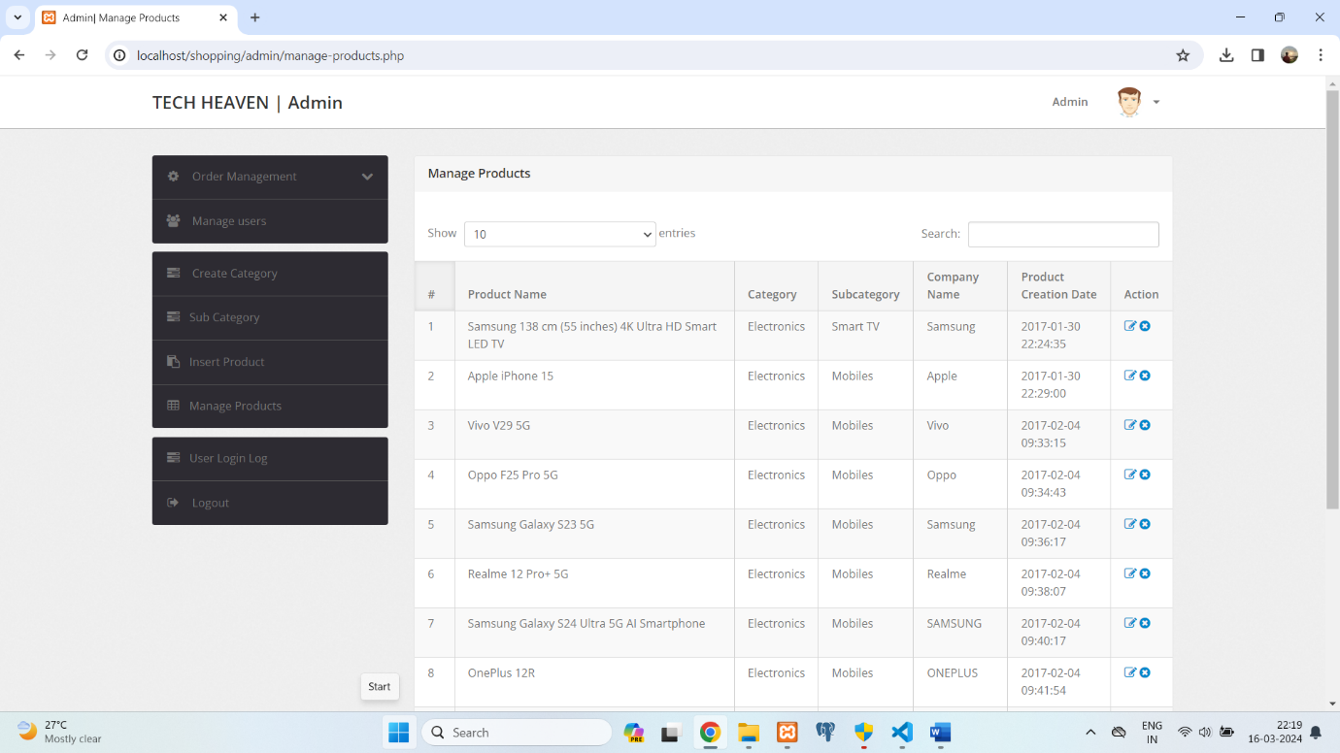

**Cart:**

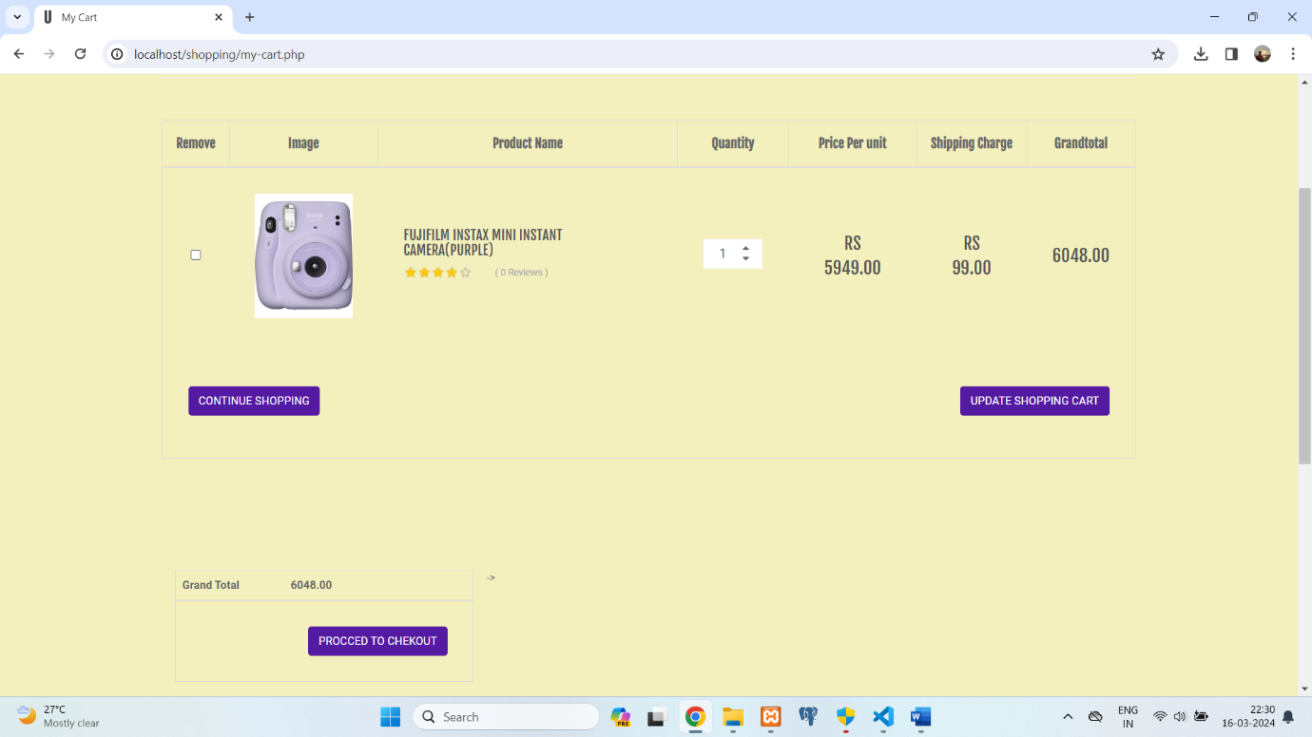

**Profile:**

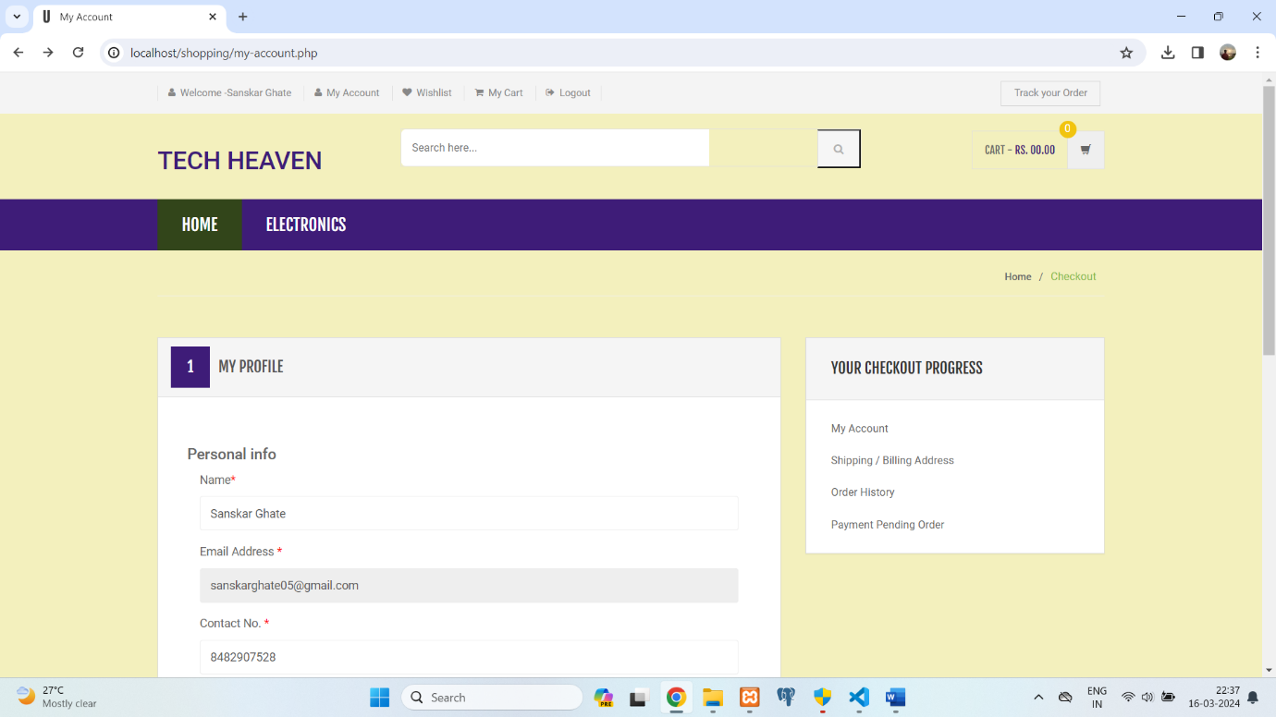

**Payment:**

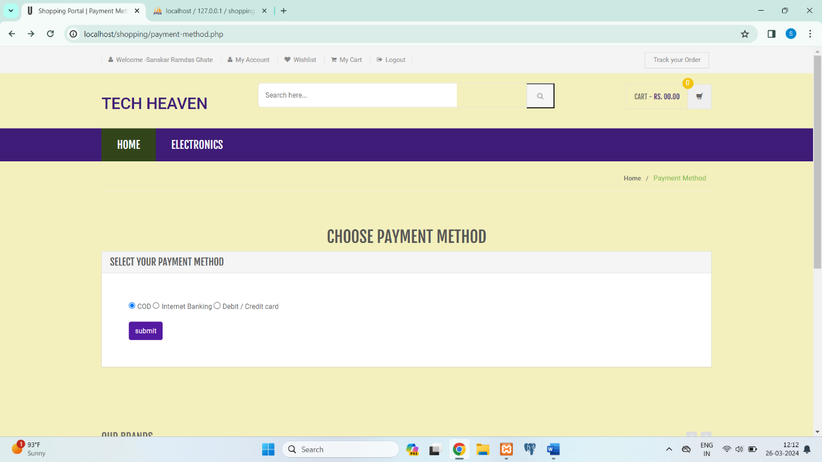

**Database:**

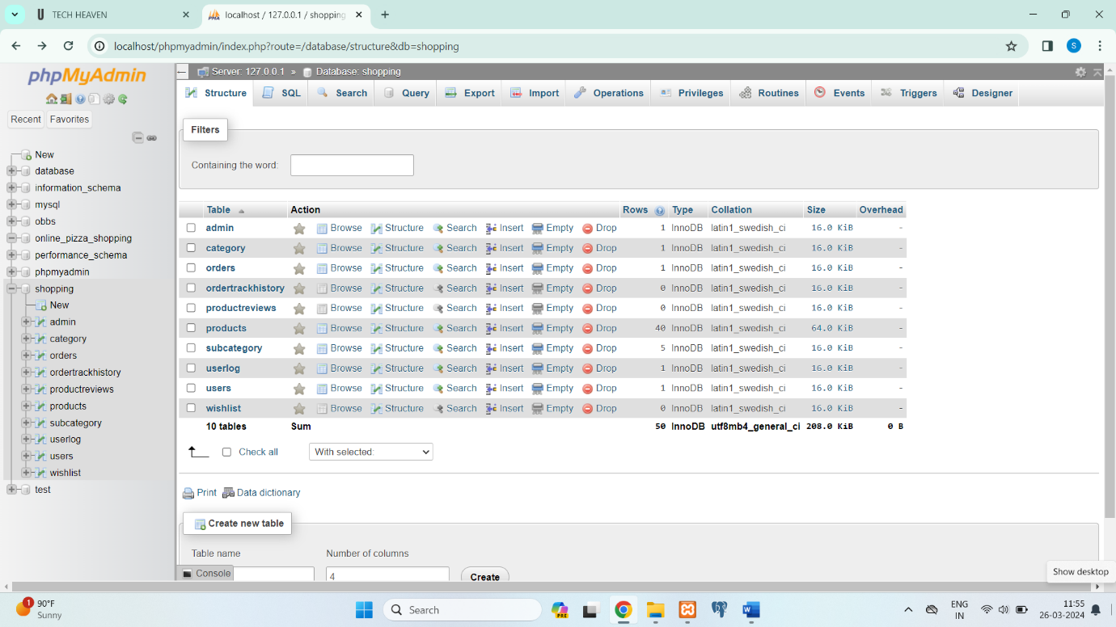

**7.Conclusion**

The **TECH HEAVEN** offers an integrated solution for managing various aspects of shopping operations. By automating administrative tasks, improving data management, and enhancing communication among different members, the system contributes to the efficient management and conservation.

**8. References**

* <https://www.w3schools.com>
* <https://www.geeksforgeeks.org>
* <https://www.youtube.com>
* <https://getbootstrap.com/>